STROBE Statement—checklist of items that should be included in reports of observational studies

Ultra-Running, the Upcoming Sport of the Endurance World: Is Emotional Intelligence associated with performance?

|  |  |  |  |  |
| --- | --- | --- | --- | --- |
|  | Item No. | Recommendation | Page  No.  (write ‘not done’ if the item isn’t found in the paper) | Relevant text from manuscript  (or brief description of what was missing) |
| **Title and abstract** | 1 | (*a*) Indicate the study’s design with a commonly used term in the title or the abstract | Not done | Samtleben did cross-sectional study but not indicated in abstract or titile. |
| (*b*) Provide in the abstract an informative and balanced summary of what was done and what was found | 1 | Background: Present study only aims at adding to the scarce literature regrading the sport of ultra-running and factors that improve athletic performance;  Objective: To determine how tripartite-EI contribute to predicting the ultra-runners 100 km personal best after controlling confounding performance, and whether mediating variables affecting the relationship between EI and personal best;  Design: cross-sectional study based on online surveys;  Settings: Participants were recruited online through various  social media platforms and ultra-running events;  Measurement: a list of  demographics, running related questions and three psychometric measures to assess each level of Tripartite EI;  Trait Emotional Intelligence Questionnaire Short Form, Situational Test of Emotion Understanding- Brief, and  Situational Test of Emotion Management-Brief;  Result: Tripartite EI’s influence on ultra-runners 100km personal best is entirely mediated by an athlete’s training load;  Limitations: not mentioned in abstract;  Conclusion: EI related factors (i.e., self-control, self-motivation) that could theoretically enhance an  athlete’s training. |
| Introduction | | | |  |
| Background/rationale | 2 | Explain the scientific background and rationale for the investigation being reported | 2 | This undeniable  reality of endurance competitions, especially  prevalent in ultra-marathon running, reveals  the potential impact that emotional  intelligence (EI) may have on ultra-running  performance, as runners have to regulate intense emotions associated with many of the  stressors and challenges, they face throughout  a race. |
| Objectives | 3 | State specific objectives, including any prespecified hypotheses | 2 | This pilot study explored the nature of the relationship between EI and ultra-running  performance at the 100km distance. Examining the  existing literature regarding EI, as well as its role within endurance spot. |
| Methods | | | |  |
| Study design | 4 | Present key elements of study design early in the paper | 6 | Final sample contained 288 participants. Recruitment was conducted online. Paticipants completed a Qualtrics questionnaire, which contained sections addressing demographics, ultra-running experience, training, race strategy, and the 3 separate components of Tripartite-EI. |
| Setting | 5 | Describe the setting, locations, and relevant dates, including periods of recruitment, exposure, follow-up, and data collection | 6 | Recruitment was conducted  online through events on raceroster.com and social media platforms including Facebook,  Reddit, and Strava. Participants completed a Qualtrics questionnaire that was made  accessible through social media posts or e-mails from race directors, both containing a  brief description of the study. $50 Amazon gift card was rewarded as incentive to participate. The study received ethics approval from Trent  Universities’ Research Ethics board. |
| Participants | 6 | (*a*) *Cohort study*—Give the eligibility criteria, and the sources and methods of selection of participants. Describe methods of follow-up  *Case-control study*—Give the eligibility criteria, and the sources and methods of case ascertainment and control selection. Give the rationale for the choice of cases and controls  *Cross-sectional study*—Give the eligibility criteria, and the sources and methods of selection of participants | 6 | Cross-sectional study:  Eligibility criteria: participants are required to post their number of past races, preferred racing distance, their PB at the 100k distance.  Source/selection: Final sample contained 288 participants. Recruitment was conducted online through events on raceroster.com and  social media platforms, including Facebook, Reddit, and Strava or e-mail from race directors. $50 Amazon gift  card was rewarded as incentive to participate. |
| (*b*)*Cohort study*—For matched studies, give matching criteria and number of exposed and unexposed  *Case-control study*—For matched studies, give matching criteria and the number of controls per case | neither | / |
| Variables | 7 | Clearly define all outcomes, exposures, predictors, potential confounders, and effect modifiers. Give diagnostic criteria, if applicable | 7-8 | Outcomes: self-reported 100km personal best time;  Exposures/ Predictors: TEIQue-SF(trait level of tripartite-EI) ; STRM-B(ability level of tripartite-EI); STEU-B( knowledge level of tripartite-EI);  Potential confounders: age, sex, number of races, preferred racing distance;  Effect modifiers: training and racing strategy, training section per week. |
| Data sources/ measurement | 8* | For each variable of interest, give sources of data and details of methods of assessment (measurement). Describe comparability of assessment methods if there is more than one group | 6-7 | The demographic section addressed participant  age and sex. The ultra-running experience section asked questions to gather data  regarding the number of past races, preferred racing distance, their PB at the 100k distance, and details about the course they ran on. Training and race preparation/strategy questions  assessed weekly training habits, that is, from 0 to 8 how many training sessions per week,  average weekly km and, level of detail in their race plan/strategy, where 0 = no plan for overall time, splits, nutrition, gear, and course research and 5 = detailed plan for overall time, splits, nutrition, gear, and course research. The Trait Emotional Intelligence Questionnaire – Short Form (TEIQue-SF)(Petrides, 2009) was  used to measure the Trait level of tripartite-EI. This 30 item self-report test was rated on a 7-  point likert scale and provides a global Trait-EI score. The Situational Test of Emotion  Management – Brief (STEM-B) (Allen et al.,2014) was used to measure the ability level of  tripartite-EI. This 18 item self-report test required participants to select the most appropriate action for managing an emotion  eliciting situation. The Situational Tests of Emotion Understanding-Brief (STEU-B) (Allen et al., 2014) was used to measure the knowledge level of tripartite-EI. This 19 item self-report test required participants to select the emotion they would most likely feel in response to a emotion eliciting situation. |
| Bias | 9 | Describe any efforts to address potential sources of bias | 7-8 | Missing data: when creating TEIQue-SF, replacing missing data by using Multiple Imputation. For STEU-B&STEM-B’s data being failed to answer, mark as missing since both STEU-B&STEM-B suffered from reliability issues |
| Study size | 10 | Explain how the study size was arrived at | 6 | Final sample contained 288 participants. |

Continued on next page

*Question 2 (4 points)*

*As mentioned in class, we have 3 overlapping groups to consider: (1) the target population to whom we would like to generalize the results of the study; (2) those who enrolled in the study (n=288); and (3) those with non-missing values of the predictor and the outcome who were analyzed (N=125). Samtleben doesn’t precisely define the target population, but does discuss it within the context of differences between the target and sample populations.*

1. *As precisely as possible, what do you believe the target population to be based on Samtleben’s description?*

The target population is the ultrarunners who have completed at least one 100-kilometer race and have access to the internet or receive email from race directors.

1. *What might you ask the investigator to clarify your definition of the target population?*

Q1: Was the target population focused on a specific region or the global range?

Q2: Were there any ability criteria for inclusion or exclusion among ultrarunners?

*Question 3 (12 points)*

*We will eventually conduct a simple linear regression with emotional intelligence as the predictor (indepen- dent variable; teique_sf) and best ultra-running time as the outcome (dependent variable; pb100k_dec). Some participants might be dropped from our analysis because of missing values on either of these variables. The term “selection bias” describes systematic differences between participants who were enrolled vs. those who were analyzed. Your task is to assess the degree of bias, if any, caused by dropping observations with missing values. Do this informally (that is, without performing statistical tests and generating p-values) using the Visualize, Analyze, Interpret (VAI) framework.*

*Visualize (4 points): Perform a descriptive analysis of the two variables we are interested in studying for this analysis. Assuming we will remove observations missing either of these variables, how many observations will be removed? What will be the size of the sample and the size of the analytic dataset? Note: This number might differ from the paper, due to different variables used.*

*Analyze (4 points): Check for systemic differences between those in the analytic dataset and those excluded from the analytic dataset. Look for potential systemic differences in the following variables: pb_surface, pb_elev, avg_km, steu_b, stem_b. To do this, create a Table 1 stratified by inclusion in the analysis, with standardized mean differences.*

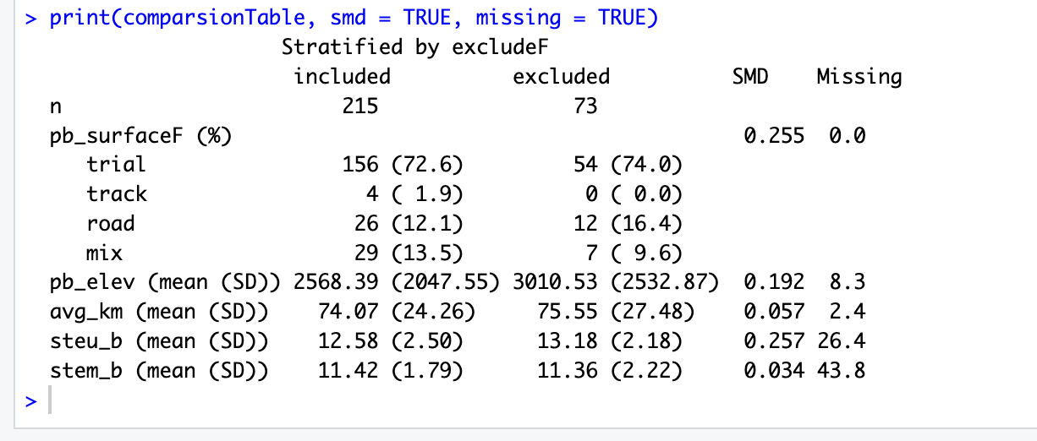

*Interpret (4 points): Based on the Table 1 you created, do you notice any systemic differences in the other variables that lead you to believe there may be bias in your analysis? Are there other sources of bias that you may not be able to interpret just by looking at this Table 1?*

Based on Table 1, most variables are very similar between included and excluded participants, suggesting little systemic bias. The only modest imbalances are in *pb_elev* (elevation gain, SMD ≈ 0.20) and *steu_b* (emotional understanding, SMD ≈ 0.24), where excluded runners tended to have higher values. This indicates a small risk of selection bias if these factors are related to performance or emotional intelligence.

Other sources of bias not detectable from Table 1 include measurement error in self-reported PB times (course type, elevation), unmeasured confounding (e.g., age, training history, injury), and self-selection bias from voluntary survey participation. Overall, selection bias is likely limited but should be acknowledged.